Goto manage Jenkins>available plugins>DOckerPipeline

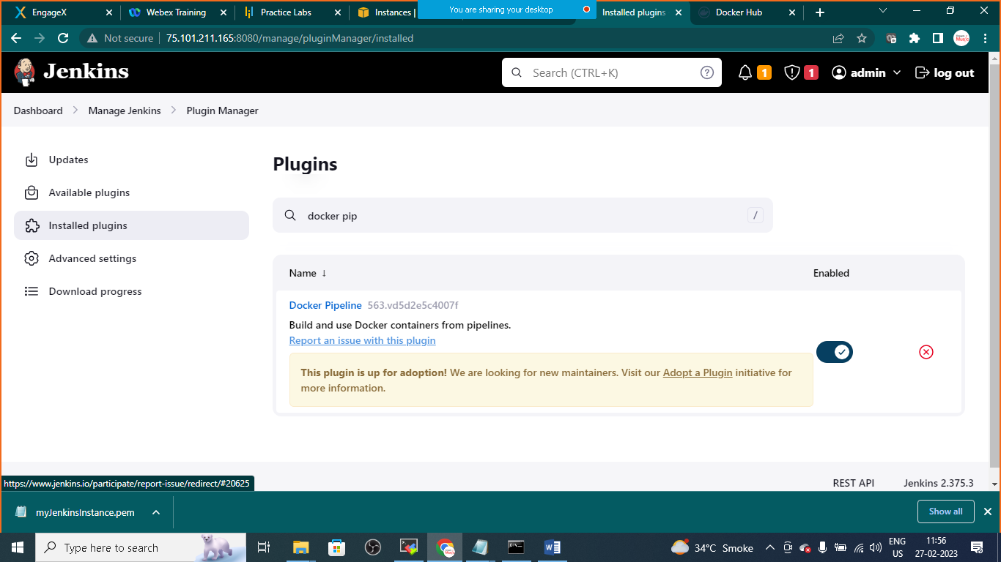

Goto>Dashboard>new job>choose pipeline project

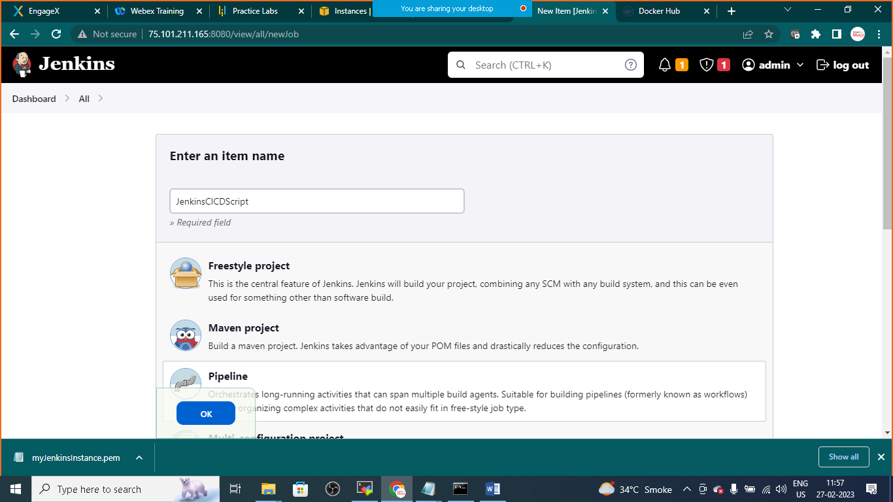

Pipline:

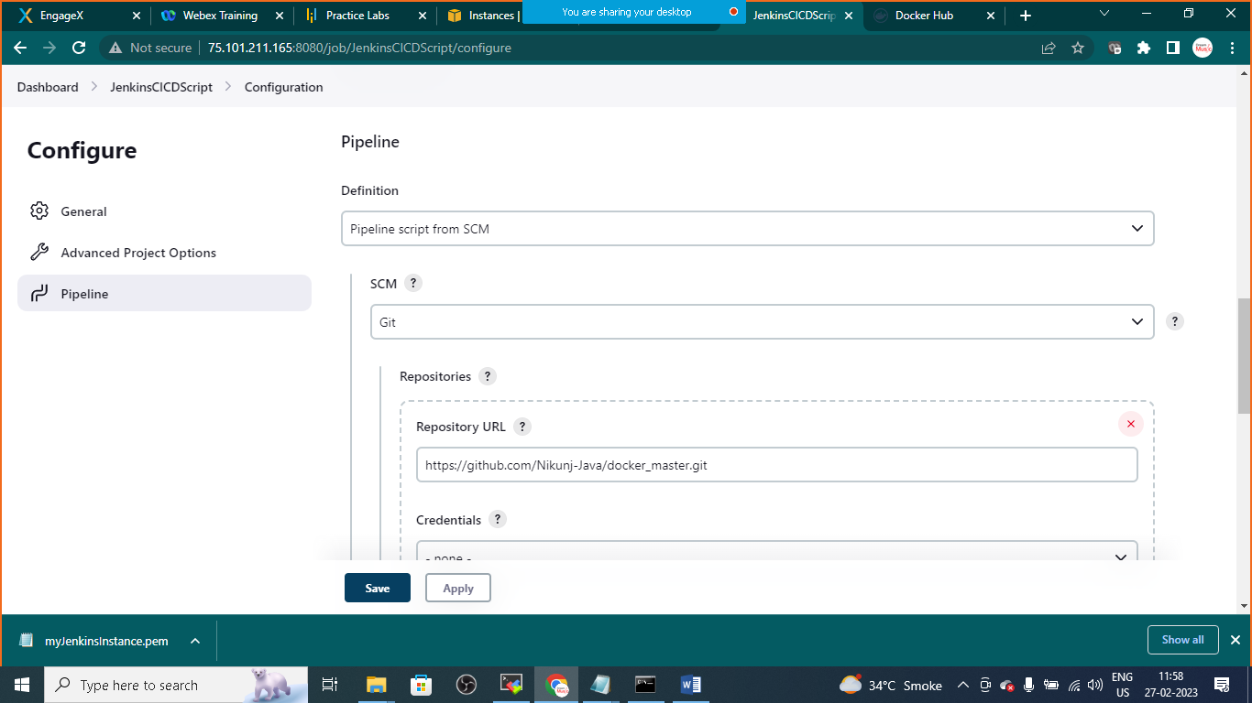

Link: <https://github.com/Nikunj-Java/docker_master.git>

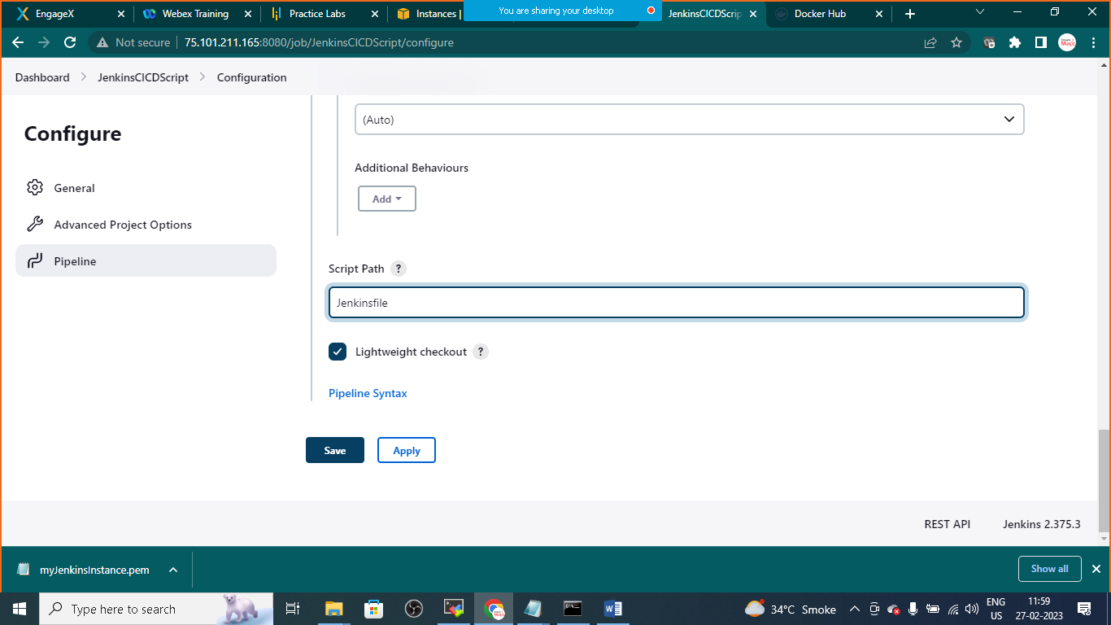

Click on apply and save

Click on Build Now

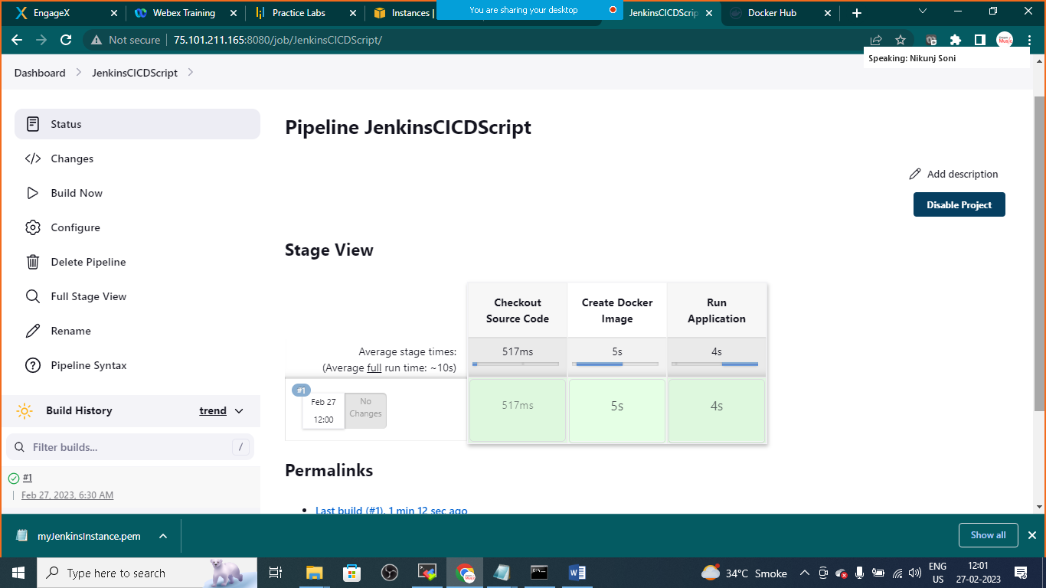

Open moba x-term and check for running containers and docker images

>sudo docker images

>sudo docker container ls

